# **CTF Topic: PDF Analysis With PDF**



# **1. Introduction**

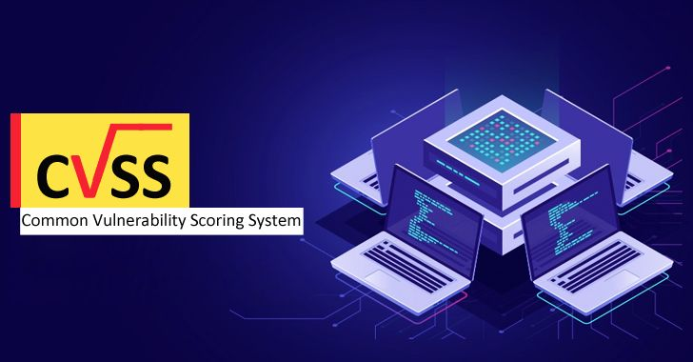

The Common Vulnerability Scoring System (CVSS) is a public framework for rating the severity and characteristics of security vulnerabilities in information systems. It provides a numerical score ranging from 0 to 10 to indicate the severity of a vulnerability, with 10 being the most severe. CVSS is vendor-neutral, enabling an organization to score its IT vulnerabilities across a wide range of software products - from operating systems and databases to web applications - using the same scoring framework.

# **2. Tools and requirements**

CVSS calculator

# **3. Scenario**

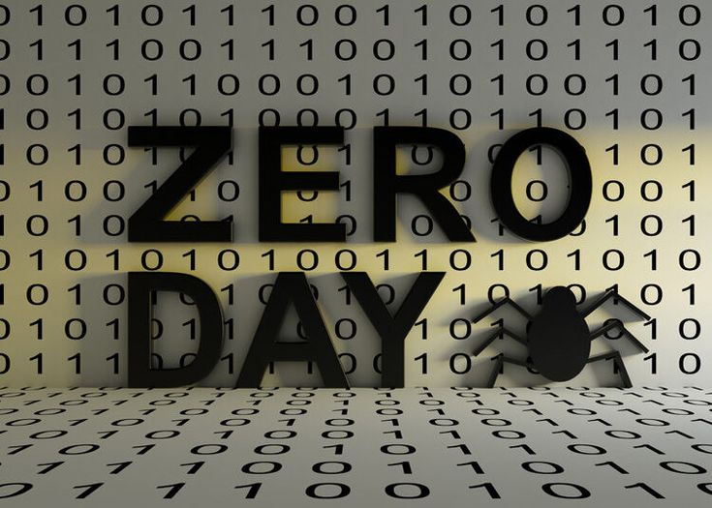

A zero day vulnerability has been found by a bug bounty hunter. It was founded by an employee associated with ING skill. We are going to perform its impact ratio on the market and its damage. According to the founder of this vulnerability he stated that

1. Attack vektor(AV) = Network
2. Attack Complexity(AC) = High
3. Attack requirement(AT) = None
4. Privileges Required(PR) = low
5. User Interaction(UI) = Active
6. Confidentiality(VC) = low
7. Integrity(VI) = none
8. Availability(VA) = high
9. Confidentiality(SC) = none
10. Integrity(SI) = high
11. Availability(SA) = high
12. Safety (S) = Negligible
13. Automable(AU) = Yes
14. Recovery(R) = Irrecoverable
15. Value Density(V) = Concentrated(C)
16. Vulnerability Response Effort(RE) = Low
17. Provider Urgency(U) = Red
18. Attack Vector(MAV) = Network
19. Attack Complexity(MAC) = low
20. Attack REquirements(MAT) = Not Defined
21. Privileges REquired(MPR) = None
22. User Interactions(MUI) = Passive
23. Confidentiality(MVC) = None
24. Integrity(MVI) = low
25. Availability(MVA) = High
26. Confidentiality(MsC) = Negligible
27. Integrity(MSI) = Not Defined
28. Availability(MSA) = High
29. Confidentiality(CR) = Medium
30. Integrity(IR) = Low
31. Availability(AR) = High
32. Exploit Maturity(E) = Attacked

# **4. Process to Perform**

To perform this CTF you have to go to the link given below and choose the values as per the scenario.

<https://www.first.org/cvss/calculator/4.0>

# 

# **4. Let's Begin The Challenge**

**Flag 1: What is the CVSS score of the vulnerability?**

**Answer: 8.4**

**Flag Captured.**

**Flag 2: How much impact does this vulnerability have?**

**Answer: High**

**Flag Captured.**

# 

# Hint

